Metabolite diversity among representatives of divergent Prochlorococcus ecotypes

Supplemental information

Table S1.

Table of growth rates at each light intensity for each strain. Growth rates are averages of the five transfers before the onset of the experiment.
Strain | Light intensity  (µmol photons m⁻² s⁻¹) | Phosphate levels | Average growth rate (day⁻¹)
MIT9301 | 50 | low phosphate | 0.29
MIT9301 | 10 | phosphate-replete | 0.39
MIT9301 | 50 | phosphate-replete | 0.67
MIT0801 | 10 | phosphate-replete | 0.40
MIT9313 | 5 | phosphate-replete | 0.29
MIT9313 | 10 | phosphate-replete | 0.43

Table S2.
Complete set of metabolites within the targeted metabolomics method used in the current project and the extraction efficiency information from Johnson et al. (1) which have been updated with unpublished data. Metabolites marked with ‘yes’ in intracellular and/extracellular columns were found in at least one Prochlorococcus strain under any light condition. We report all detected metabolites, but only concentrations for those with extraction efficiencies above 1%. Intracellular concentrations of oxidized glutathione are not available due to interference by an unknown compound. The concentration data for each metabolite is available at MetaboLights (http://www.ebi.ac.uk/metabolights/) as study accession number MTBLS567.
metabolite | extraction efficiency (%) | intracellular | extracellular
2,3-dihydroxybenzoic acid | 100.9
2,3-dihydroxypropane-1-sulfonate | 0.6 |  | yes
3-mercaptopropionic acid | 88.6
3-methyl-2-oxobutanoic acid | 10.1 |  | yes
3-methyl-2-oxopentanoic acid | 50.1 | yes | yes
4-aminobenzoic acid | 18.5 | yes | yes
4-hydroxybenzoic acid | 88 |  | yes
4-methyl-2-oxopentanoic acid | 43.4 | yes | yes
5'-methylthioadenosine | 80.9 | yes | yes
4-amino-5-aminomethyl-2-methylpyrimidine | 0
D-glucosamine 6-phosphate | 0
dimethylsulfoniopropionate | 0
γ-aminobutyric acid | 0
4-Amino-2-methyl-5-pyrimidinemethanol | 0
nicotinamide adenine dinucleotide | 20.9 | yes
putrescine | 0 |  | yes
acetyltaurine | 0
adenine | 0
adenosine | 6.5
adenosine 5'-monophosphate | 0.2 | yes
alpha-ketoglutaric acid | 0 | yes
arginine | 0 | yes
aspartic acid | 0 | yes
glycine betaine | 0 | yes
biotin | 52.8
caffeine | 23.5
chitobiose | 0.3 | yes
chitotriose | 5.6
choline | 0
ciliatine | 0
citrate | 0.9
citrulline | 0 | yes
cyanocobalamin | 79.1
cysteine | 0
cytosine | 0
desthiobiotin | 6.5
dihydroxyacetone phosphate | 0 | yes
ectoine | 0
folic acid | 41.2
fosfomycin | 0
fumaric acid | 0
glucose 6-phosphate | 0 | yes
glutamic acid | 0 | yes
glutamine | 0 | yes
glyphosate | 15.1
glutathione | 1.1 | yes | yes
glutathione oxidized | 1.5 | not available | yes
guanine | 0
guanosine | 7.7 | yes | yes
hemin | 0 | yes
indole 3-acetic acid | 16.8
inosine | 8.1
inosine 5'-monophosphate | 0 | yes
isoleucine | 1.41 | yes | yes
kynurenine | 41.7 |  | yes
leucine | 3.3 | yes
malic acid | 0.7
methionine | 0 | yes
muramic acid | 0
n-acetyl glucosamine | 0
n-acetyl glutamic acid | 1.1 | yes
n-acetyl muramic acid | 2.8
ornithine | 0
orotic acid | 0
pantothenic acid | 51.9 | yes | yes
phenylalanine | 39.7 | yes | yes
phosphoenolpyruvate | 0
phycocyanobilin | 0
proline | 0 | yes
pyridoxine | 6.8
riboflavin | 87.6
S-(5'-adenosyl)-L-homocysteine | 43.3 | yes
S-adenosyl-L-methionine | 0 | yes
alanine (isom. sarcosine) | 0
serine | 0
sn-glycerol 3-phosphate | 0
taurocholic acid | 92.8
spermidine | 0 | yes | yes
succinic acid | 0 |  | yes
syringic acid | 32.9
taurine | 0
thiamine | 2
thiamine monophosphate | 0
threonine / homoserine | 0
thymidine | 52.6 |  | yes
tryptamine | 21.3
tryptophan | 46.7 | yes | yes
tyrosine | 2.1 | yes | yes
uracil | 0 | yes
uridine 5'-monophosphate | 0 | yes
valine | 0 | yes | yes
xanthine | 0.3 |  | yes
xanthosine | 10.4 |  | yes

Table S3.
Mean (± one standard deviation) cell-specific concentrations of glycine betaine (fg cell⁻¹) in cultures of three strains of Prochlorococcus grown at a range of light intensities. *Biomass of cells from each strain are from Cermak et al. (2) in which the authors used a microfluidic mass sensor. We assumed 50% of the cell was carbon (3). These values were used to calculate the percent of each strain’s intracellular carbon content that can be attributed to the carbon in glycine betaine. †Measured value for NATL2A, a related LLI strain of Prochlorococcus.
Strain | Clade | Growth light intensity (µmol photons m⁻²s⁻¹) | Median cellular biomass (fg)* | Glycine betaine  (fg cell⁻¹) | % of biomass
MIT9301 | HLII | 10 | 60 ± 3 | 4.5 x 10⁻⁴ (± 8.0 x 10⁻⁴) | 0.002%
MIT9301 | HLII | 50 | 60 ± 3 | 0
MIT0801 | LLI | 10 | 91 ± 5† | 0
MIT9313 | LLIV | 5 | 158 ± 6 | 3.0 (± 1.3) | 4%
MIT9313 | LLIV | 10 | 158 ± 6 | 4.7 (± 2.4) | 6%

Supplemental figures:
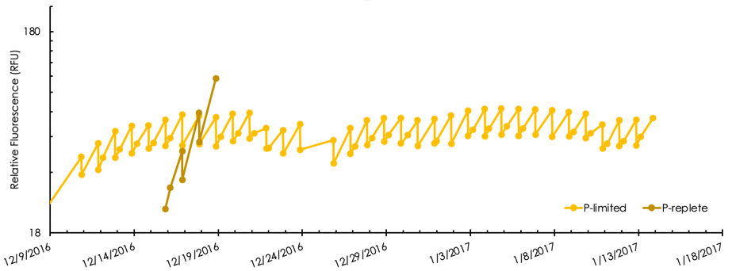
Figure S1: The yellow curve shows a culture of Prochlorococcus MIT9301 maintained in a semi-continuous state of P-limitation through daily dilutions with media containing 20-fold less phosphorus than the replete media. The brown curve shows a culture that from that point forward was diluted (at the same dilution rate) in media replete with phosphorus.

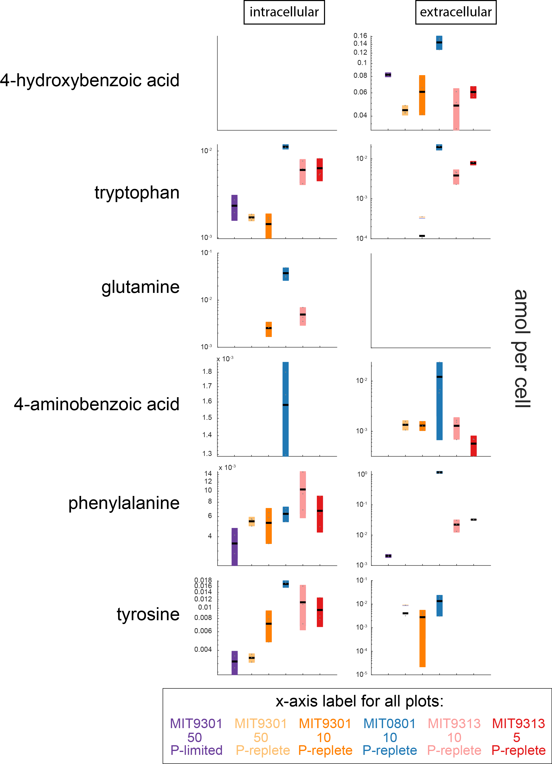
Figure S2. Intracellular metabolites from Figure 3, plotted on a log scale as discrete amol per cell values for each metabolite.
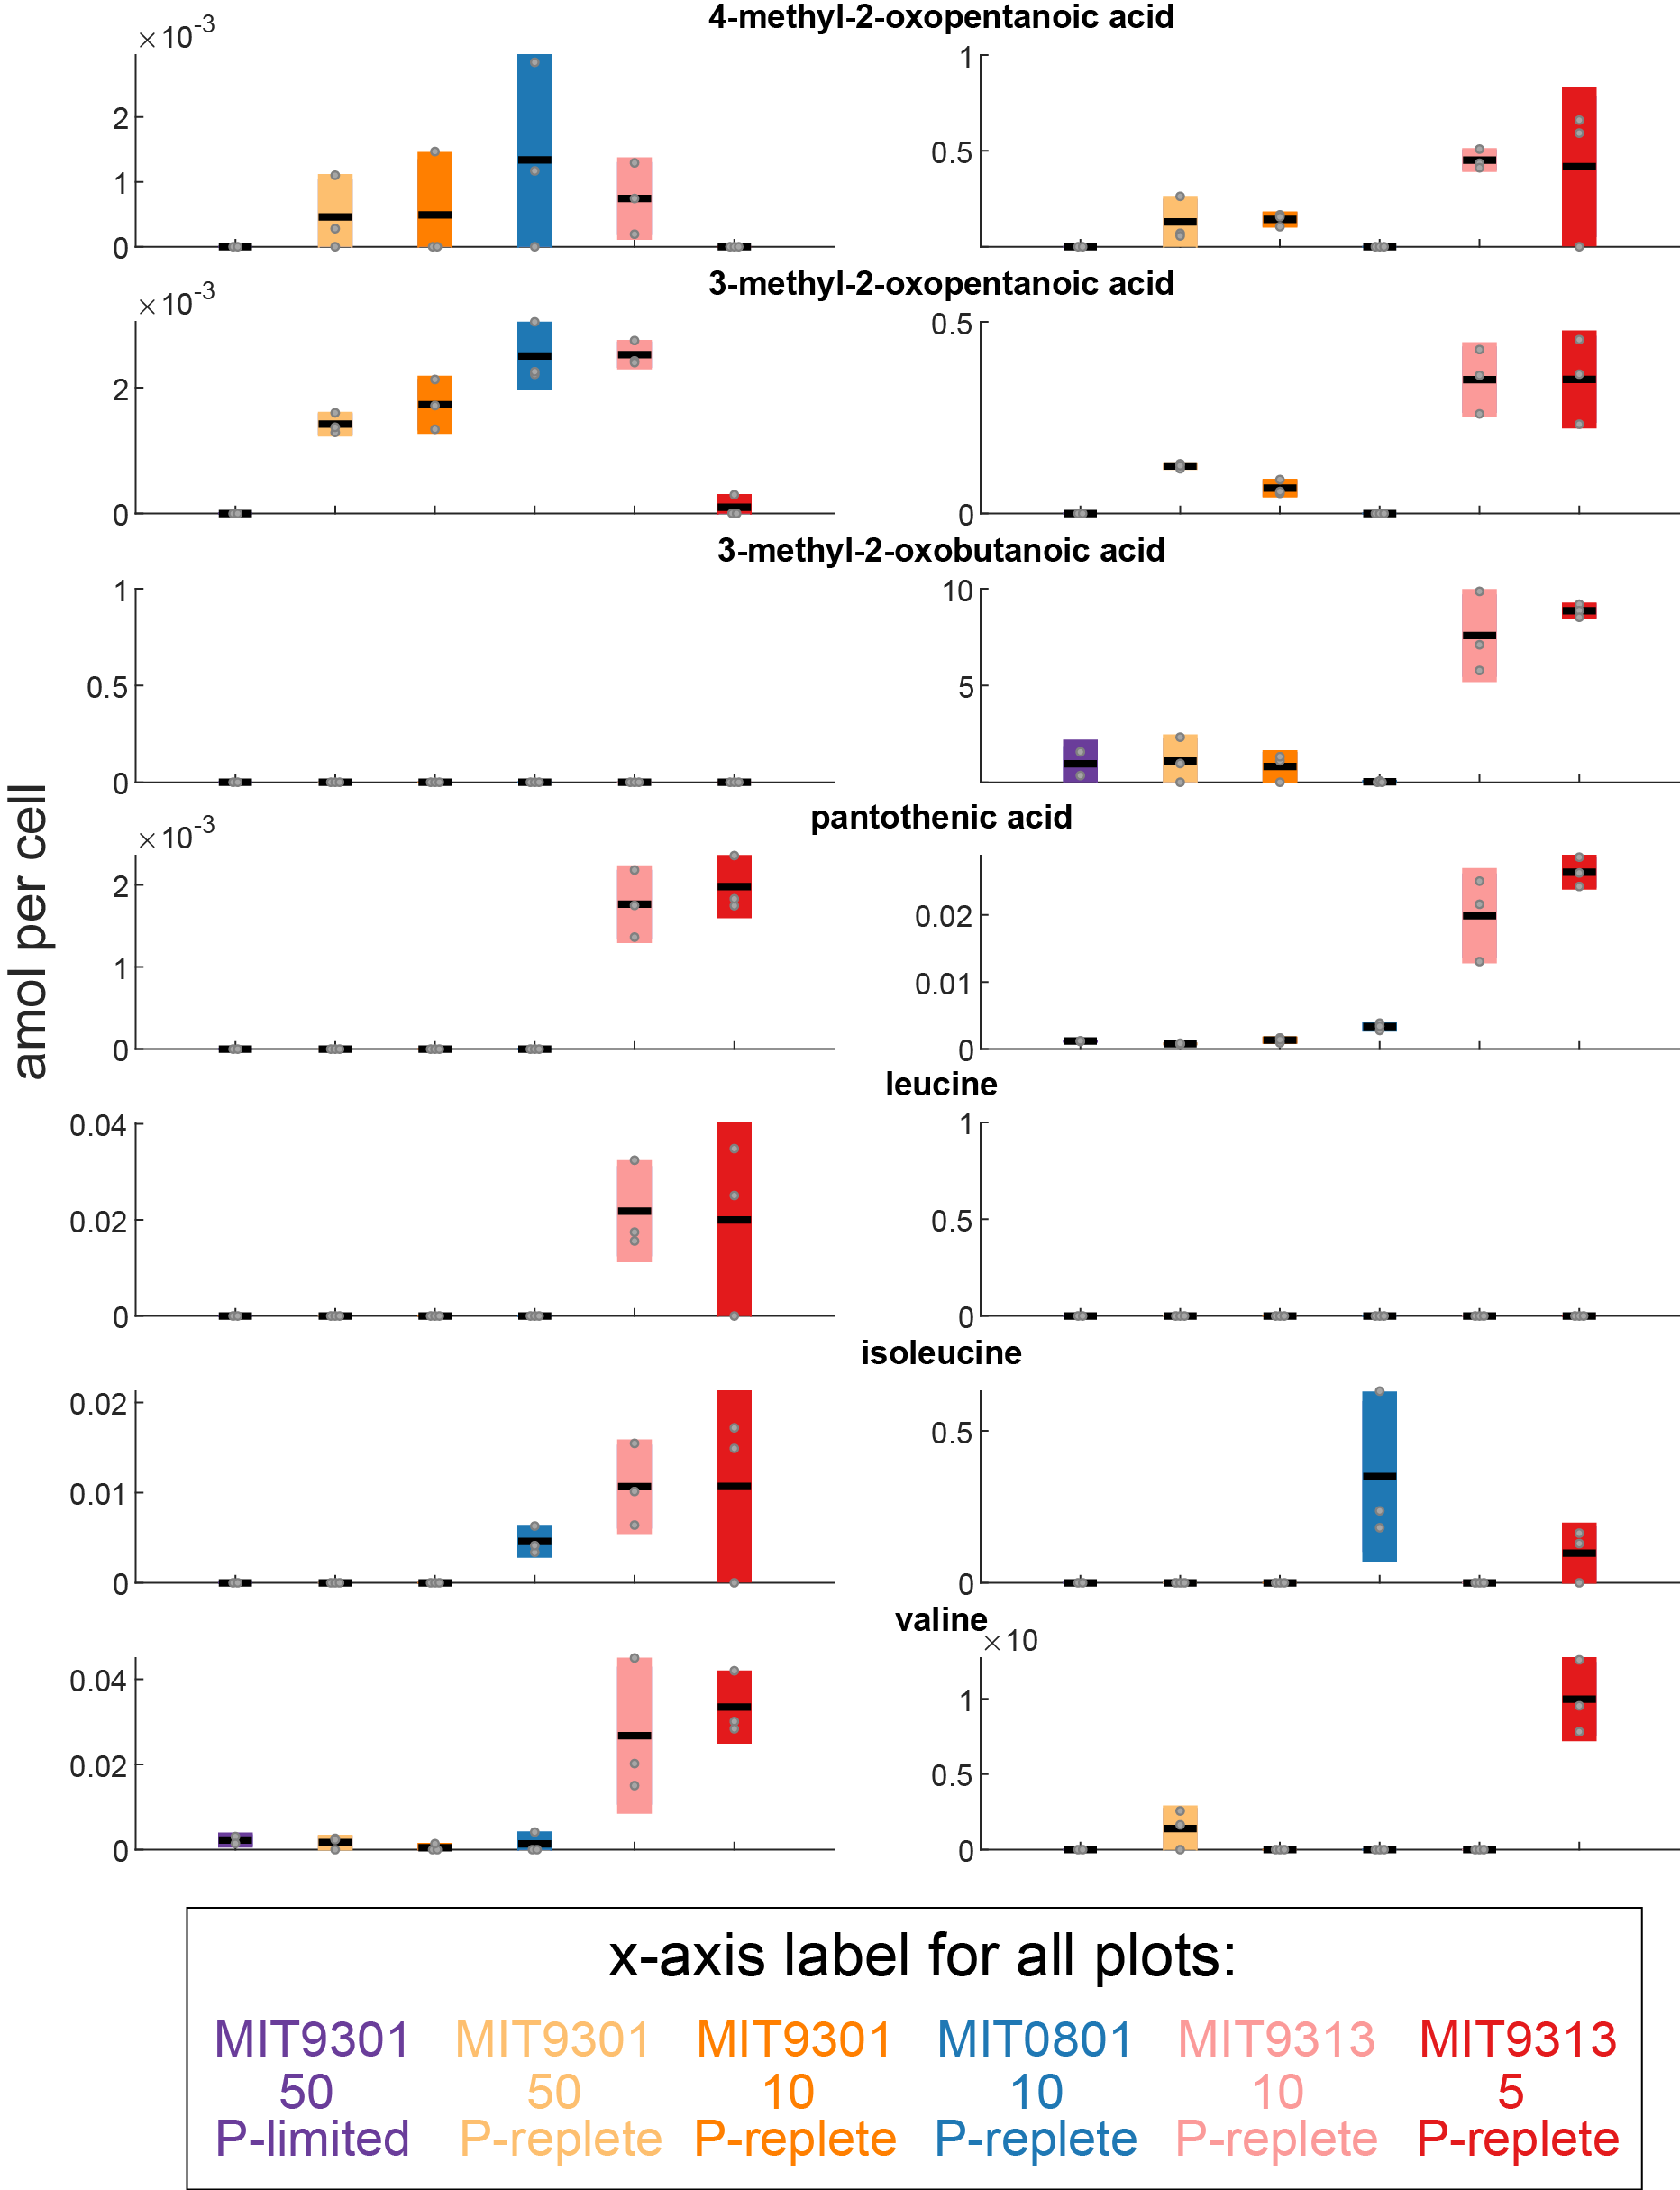
Figure S3. Intracellular metabolites from Figure 5, plotted as discrete amol per cell values for each metabolite.

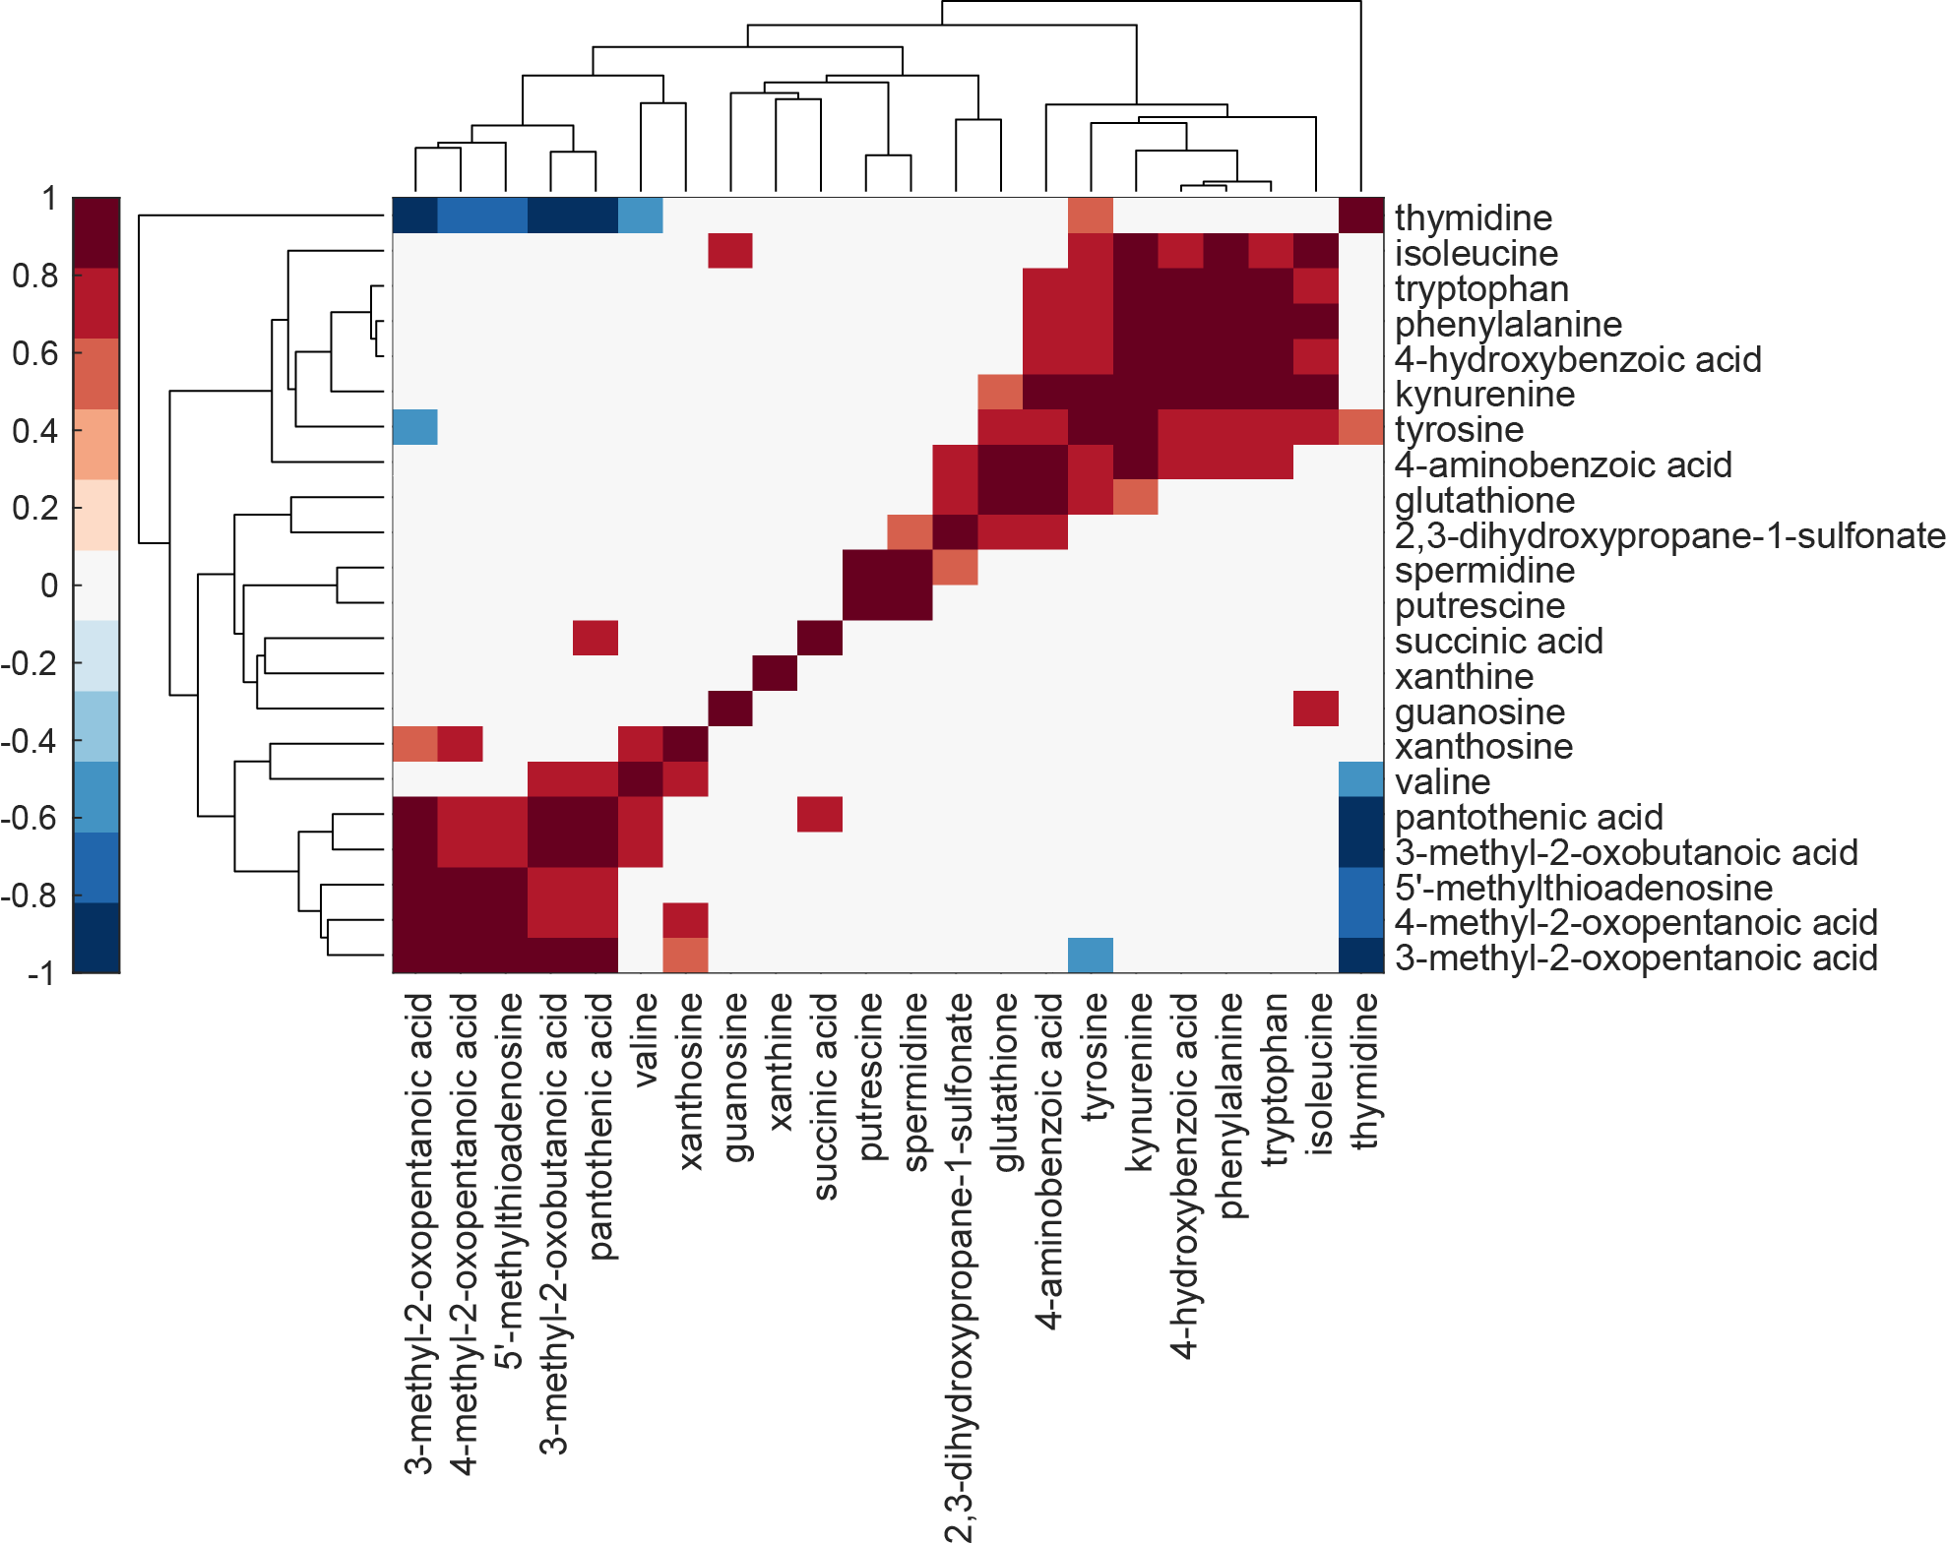
Figure S4. Clustergram of correlations for all extracellular metabolites collected from cells grown in replete conditions. Statistically significant positive (red) and negative (blue) correlations are Pearson correlations with p-values adjusted using a False Discovery Rate of 5%.

References cited
1. Johnson WM, Kido Soule MC, Kujawinski EB. 2017. Interpreting the impact of matrix on extraction efficiency and instrument response in a targeted metabolomics method. Limnology and Oceanography Methods 15:417-428.
2. Cermak N, Becker JW, Knudsen SM, Chisholm SW, Manalis SR, Polz MF. 2017. Direct single-cell biomass estimates for marine bacteria via Archimedes' principle. ISME J 11:825-828.
3. Atlas RM. 1988. Microbiology. Macmillan Publishing Company, New York, NY.

